**GYM**

**AND**

**FITNESS   
[HEALTH]**

**AUTOMATION**

**System**

**ACKNOWLEDGEMENTS**

I would like to express my sincere gratitude towards **the Information Technology Department of Sathaye College.**

After months of hard work, finally I am happy to present my final year Project. The Project making was full of new experiences.

Though a difficult job it was made simpler by the timely guidance received, which helped me greatly in the completion of my project. But it wouldn’t be right to do so without thanking to those who have helped me in converting our thought into reality. So we would like to take full advantage of this opportunity to thank each and every person who has helped me throughout the completion of my project.

I am obliged to my parents & family members who always supported me greatly and encouraged me in each and every step. I give my special thanks and sincere gratitude towards the Principal Dr. M.R. Rajwade, Head of Department **Prof.Arvind Khadye.**

I owe my sincere thanks to my Project guide **Mr. Dhanraj Jadhav** for his constant support and encouragement without which the successful completion of this project would have been impossible.

Will be forever indebted to all friends who really encouraged me. And last but not the least the entire college staff. Finally I would like to thank each and every individual who was directly or indirectly contributing for this project.

**-Thank you.**

**Abstract**

Any business that does not have a website is missing out on one of the most powerful marketing tools available to them. The main reason that it is important for businesses to have a website is how people are likely to find you. These days most people will go online and research products and companies before they make a purchase. For this reason of dependency on online, we develop a website for a gymnasium in which customer can get all information about the gymnasium and he/she can access or enrol at the gym via online. Usually, the client uses MS Excel or paper, and maintains their records, however it is not possible them to share the data from multiple system in multi user environment, there is lot of duplicate work, and chance of mistake.

When the records are changed they need to update each and every excel file.

The Smart Gym Management System eliminates most of the limitations of the existing software. Increasing efficiency and effectiveness, automation, accuracy, user-friendly interface, information availability, communication capacity, maintenance, cost reduction makes our system smarter than the existing system. We integrate some new and prominent features along with all the necessary features. Such as real time chat system for clients and trainers, separate trainer panel, diet plan panel, calories calculator and many more.

**Introduction**

We all know health is a wealth.

We do not need a fancy car, big apartment, a doctor degree without a health.

Being healthy is a first thing we need to keep in mind. Because most of time our attitude depends on how we feel.

Being healthy and fit gives us energy to do anything. Physical fitness is very necessary for a healthy and tension free life.

Physical fitness includes diet, exercise and sleep.

These three basic things have their own importance in each individual's life and everyone should be sensible with regard to these for a healthy life.

My research and my system is very helpful and useful for the gym trainers also.

**Overview of the Project**

My proposed “GYM AND FITNESS [HEALTH] AUTOMATION SYSTEM” is for those who run a gym business and for those who are the certified personal trainers.

Before doing anything I did a decent research on major difficulties for gym owners.

We examined carefully about how to make a huge registering system without failure as well as different functions for different kind of user depending on their privilege.

You can keep records on your members, their membership, and have a quick and easy communication between you and your member.

The Gym owners or gym managers requires a system that will handle all the necessary and minute details easily and proper database security accordingly to the user.

Trainers are also need to keep their clients data secure and sometimes diet is also secure.

Trainers can also assign different diets as per the day to day exercise.

Sometimes trainers get confuse or forget about the exercises they already completed with their gymers so they need proper platform to keep all those things.

They require software, which will store data about members, employees, products, receipts of members, session of the member, personal information of the members & all transactions that occur in Gym.

**Objectives**

The objectives of this study are summarized below: -

➢ The main objective of the project is to design and develop a user friendly efficient computerized Gym System.

➢ An accurate system without any data redundancy.

➢ Secured data storage for Authority end.

➢ Secure the user ends data by providing each user’s own personal credentials.

➢ A flexible system which can maneuver the members-staff relationship in an effective manner.

➢ To provide better graphical user interface.

➢ Computerization can be helpful as means of saving time & money.

* I’m also introduced real time chat system module for the trainers and the members. So the gym trainers and the gym members can easily communicate with each other anytime and anywhere.
* I’m also introduced Gmail conformation system when the trainer and new member are going to register.
* When the existing users’ gym membership is going too expired before some days the system will automatically sends the notification mail to the particular member.
* I’m introducing the mail system for the conformation and for notifying the members.
* The administrator has all the control about the system functions and the trainers and the gym members.
* Proper platform or system support for the trainers to keep all the data about their gym members(diet, exercises, their goals).

**SCOPE**

There is huge scope for my research and my project because gym owners or gym managers don’t have any computer software system support to handle their gym related things

The gym is working manually.

The current system is time consuming and also it is very costly, because it involves a lot of paperwork.

To manually handle the system was very difficult task.

But now-a-days computerization made easy to work.

So if they get the computerized software system to handle all the gym related things then it will be very helpful for them in many terms.

And those terms I mentioned in the different topic in the document.

**Defining a problem**

Defining a problem is one of the important activities of the project.

The objective is to define precisely the business problem to be solved & thereby determined the scope of the new system.

This phase consist of 2 main tasks.

The 1st task within this activity is to review the organization needs that originally initiated the project.

The 2nd task is to identify, at an abstract or general level, the expected capabilities of the new system.

Thus, it helps us to define the goal to be achieved & the boundary of the system.

A clear understanding of the problem will help us in building a better system & reduce the risk of project failure.

It also specifies the resources that have to be made available to the project. Three important factors project goal, project bounds & the resource limits.

**Feasibility study**

The systems objectives outlined during the feasibility study serve as the basic from which the work of system design is initiated.

Much of the activities involved at this stage is of technical nature requiring a certain degree of experience in designing systems, sound knowledge of computer related technology and through understanding of computers available in the market and the various facilities provided by the vendors.

Nevertheless, a system cannot be designed in isolation without the active involvement of the user.

The user has a vital role to play at this stage too. As we know that data collected during feasibility study wills we utilized systematically during the system design. It should, however be kept in mind that detailed study of the existing system is not necessarily over with the completion of the feasibility study.

Depending on the plan of feasibility study, the level of detailed study will vary and the system design stage will also vary in the amount of investigation that still needs to be done.

This investigation is generally an urgent activity during the system. Sometimes, but rarely, this investigation may form a separate stage between feasibility study and computer system design. Designing a new system is a creative process, which calls for logical as well as lateral thinking.

The logical approach involves systematic moves towards the end product keeping in mind the capabilities of the personnel and the equipment at each decision making step. Lateral thought implies encompassing of ideas beyond the usual functions and equipment. This is to ensure that no efforts are being made to fit previous solutions into new situations.

The feasibility study proposes one or more conceptual solutions to the problem set for the project.

The objective in assessing feasibility is to determine whether a development project has a reasonable chance of success.

It helps us to determine the input & output of the system. The following are the criteria that are considered to confirm the project feasibility.

**The following feasibility study was undertaken for the proposed system:-**

**Technical feasibility:-**

At first it’s necessary to check that the proposed system is technically feasible or not & to determine the technology and skill necessary to carry out the project.

If they are not available then find out the solution to obtain them.

**Economic feasibility:-**

While considering economic feasibility, it is checked in points like performance, information and outputs from the system. The developing system must be justified by cost and benefit. Criteria to ensure that effort is concentrated on project, which will give best, return at the earliest. One of the factors, which affect the development of a new system, is the cost it would require.

**Social feasibility:-**

Although generally there is always resistance, initially to any change in the system is aimed at reliving the work load of the users to extent the system is going to facilitate user to perform Operations like calculating salary amounts and deductions, generating reports with less possible errors. Thus there is no reason to make system socially unfeasible.

**Modules & Features**

There are three basic modules in this system as describe briefly in below

• Administrative module: This user is an admin type who has full rights on the system.

* Trainer module: This users has the all rights about their respected gym members.

• User module: This is a normal level of user who will be very few number of functionality of website.

**Administrative Module**

This module includes storing and retrieving the details of the data.

• Create, Update, Manage, Delete User, Trainer

• Manage trainer info and allocation of the trainer

• Manage Billing

• Manage User Enquiry through Email

• Manage Owner Info

**Trainer Module**

This module includes storing and retrieving the details of the data coming from their respected gym member.

* Manage exercises for the client
* Create diet plan for the client
* Examine the clients growth according to their goal
* Adding the new and different exercises day by day
* Chat with client if the client is far away
* Adding extra sets and reps for the client

**User Module**

Depends on the privilege user’s access to features of the application is granted. Below are the some important functionality of user module

* Login through the application
* Chat with the trainer
* Can sends the images of the machine too.
* Can add extra sets and reps for itself
* Can Calculate the growth
* Can see the diet plan for day to day activities
* Conform the subscription plan through the email.

**SYSTEM DESIGN AND ANALYSIS**

**Why is the particular topic chosen?**

* Every day I personally go to the gym for my different types of exercises.
* The existing system is based on the paper only.
* They don’t have any computerized system support to handle their gym related things.
* Even they have to remember or check their registers to conform the gym membership.
* If they want to check the how many days are left about gym member membership they every time have to check the registers.
* And they have to tell every time about the sessions to every gym member.
* They don’t have any computerized automated system to do all this things.
* When the new member comes to the gym the gym owner has to do paperwork (gym membership form, photo id) with the new member.
* When the fees are paid by the customers they give the receipt to them again there is paperwork.
* So all the gym owners are depend on the paperwork for managing their gym and gym related works.
* Because of paperwork the gym owners most of the time forgets to remember who paid the fees and who’s not paying the gym fees so there is huge loss for the gym owners.
* Sometimes the gym member left the gym without paying the gym fees.

**Existing System**

An Existing system refers to the system that is being followed till now. The gym is working manually. The current system is time consuming and also it is very costly, because it involves a lot of paperwork. To manually handle the system was very difficult task. But now-a-days computerization made easy to work.

The following are the reasons why the current system should be computerized:

* To increase efficiency with reduced cost.
* To reduce the burden of paper work.
* To save time management for recording details of each and every member and employee.
* To generate required reports easily.

**Proposed System**

The online gym system is user-friendly application.

This automated system makes all functionality easier for both owners, trainers, gym members and customers.

It is very simple in design and to implement.

The system requirements are very low.

System resources and the system will work in almost all configurations.

By using the automated gym management system we can minimal the losses of the gym in terms of collecting fees from the member.

Trainers have their personal space for their personal clients.

There is separate module for the trainers which contain all the necessary functions to keep the all record of their clients.

A real time messaging system for the trainers and the gym members which is very useful for the communication between them from anywhere and anytime.

Gmail conformation system for the gym members which is used by the administrator to inform about the seesion ending information to the particular member.

The features for gym trainer like adding new trainer details, viewing trainer details, edit the trainer details.

How to add new exercise for the members; edit the exercises, adding the sets for the members by their personal trainer.

Creating the diet plan for the all the members according to their fitness goals like weight loss, fat loss, mass gaining, cut down. Adding the all type of food with their nutrition facts like how many grams of protein, fats, carbs, calories are present.

**It has the following objectives:-**

**Enhancement:-**

The main objective of GYM AND FITNESS [HEALTH] AUTOMATION SYSTEM is to enhance and upgrade the existing system by increasing its efficiency and effectiveness.

The software improves the working methods by replacing the existing manual system with the computer-based system.

**Automation: -**

The GYM AND FITNESS [HEALTH] AUTOMATION SYSTEM automates each and every activity of the manual system and increases its throughput. Thus the response time of the system is very less and it works very fast.

**Accuracy:**

The GYM AND FITNESS [HEALTH] AUTOMATION SYSTEM provides the uses a quick response with very accurate information regarding the users etc. Any details or system in an accurate manner, as and when required.

**User-Friendly:**

The software GYM AND FITNESS [HEALTH] AUTOMATION SYSTEM has a very user-friendly interface. Thus the users will feel very easy to work on it. The software provides accuracy along with a pleasant interface. Make the present manual system more interactive, speedy and user friendly.

**Availability:**

All reports of the system can be retried as and when required. Thus, there is no delay in the availability of any information, whatever needed, can be captured very quickly and easily.

**Maintenance Cost**:

Reduce the cost of maintenance.

**Application Requirements**

**User Interface:**

* HTML has been used for developing the user layout for the system.
* JavaScript has been used for creating all the validations and client side scripting functionality.
* CSS, html, bootstrap has been used for designing the web page as well as app of the system.

**Software Interface:**

* Client on application: client can use application on their Android or IOS devices. Client can use multiple devices for the same account.
* Database: MySQL.
* Markup Language: HTML, CSS
* Scripting Language: PHP, JavaScript, JQuery
* Technology: phone gap, bootstrap, code igniter.

**Hardware interface:**

* Processor : Intel Pentium IV or more
* Mobile devices : Android 4.0 or greater and IOS 8.0 or more
* Ram : 512 MB or more
* Cache : 1 MB
* Hard Disk : 10 GB recommended

**Testing**

Software testing is the process of evaluation a software item to detect differences between given input and expected output. Also to assess the feature of A software item. Testing assesses the quality of the product. Software testing is a process that should be done during the development process. In other words software testing is a verification and validation process.

**Verification:-**

Verification is the process to make sure the product satisfies the conditions imposed at the start of the development phase. In other words, to make sure the product behaves the way we want it to.

**Validation:-**

Validation is the process to make sure the product satisfies the specified requirements at the end of the development phase. In other words, to make sure the product is built as per customer requirements.

Testing goes side by side with the implementation that is aimed at ensuring that the system works accurately and efficiently before the live operation is performed .The common view of testing held by the user is process of executing a program with explicit intention of handling errors. The application which has been developed has to be tested to prove its validity. Testing is considered to be the least creative phase of the whole cycle of system design. In the real sense it is the phase, which helps to bring out the creativity of the other phases, and makes it shine.

The GYM AND FITNESS [HEALTH] AUTOMATION SYSTEM was tested using the following two techniques of application testing:

**Unit Testing:-**

* In the line of strategy the entire individuals function and modules were put to test independently
* By following this strategy all the errors in coding were identified and corrected.
* This method was applied in combination with the White Box and Black Box testing.

Technique to find errors in each module.

* The effort of specific combination of data on system operation was tested.

* The following were the testes carried out for Graphical User Interface (GUI).
* It was seen that the pages opens properly based on related menu based commands.
* It was tested whether all relevant menus, buttons, icons and other controls are available and properly displayed.

**System Testing:-**

We use this testing method. System testing is the testing to ensure that by putting the software in different environments (e.g., Operating Systems) it still works. System testing is done with full system implementation and environment. It falls under the class of black box testing.

**Performance Testing:-**

Performance testing is the testing to assess the speed and effectiveness of the system and to make sure it is generating results within a specified time as in performance requirements. It falls under the class of black box testing.

**Multi-user System Testing:-**

Database Locking Schemes: Whenever more than one person is accessing a record/s some type of process must be used to prevent the outer users from attempting to update the same record at the same time.

This process is a locking scheme. In its simplest form, a locking scheme allows only one user at a time to update information in the database.

**System Implementation**

**Implementation Methodology:-**

We follow the MVC design pattern for developing our system. Model–view–controller (MVC) is a software design pattern for implementing user interfaces on computers.

It divides a given software application into three interconnected parts, so as to separate internal representations of information from the ways that information is presented to or accepted from the user.

* **Model:**

The model manages the behavior and data of the application domain, responds to requests for information about its state (usually from the view), and responds to instructions to change state (usually from the controller).

* **View:**

The view manages the display of information.

* **Controller:**

The controller interprets the mouse and keyboard inputs from the user, informing the model and/or the view to change as appropriate.



Diagram of A typical collaboration of the MVC components.

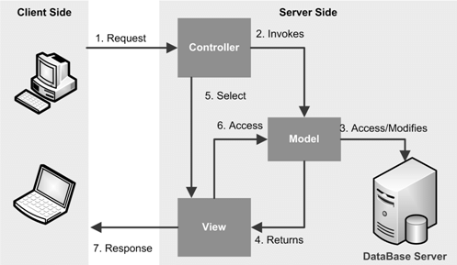

**Data Flow Diagram**

A data flow diagram (DFD) is a graphical representation of the "flow" of data through an information system, modelling its process aspects.

A DFD is often used as a preliminary step to create an overview of the system, which can later be elaborated.

[2] DFDs can also be used for the visualization of data processing.

A DFD shows what kind of information will be input to and output from the system, where the data will come from and go to, and where the data will be stored. It does not show information about the timing of process or information about whether processes will operate in sequence or in parallel.



**Level 1 DFD (Administrative Panel) :**



**Level 1 DFD (User Panel) :**



**Level 1 DFD (Trainer Panel) :**

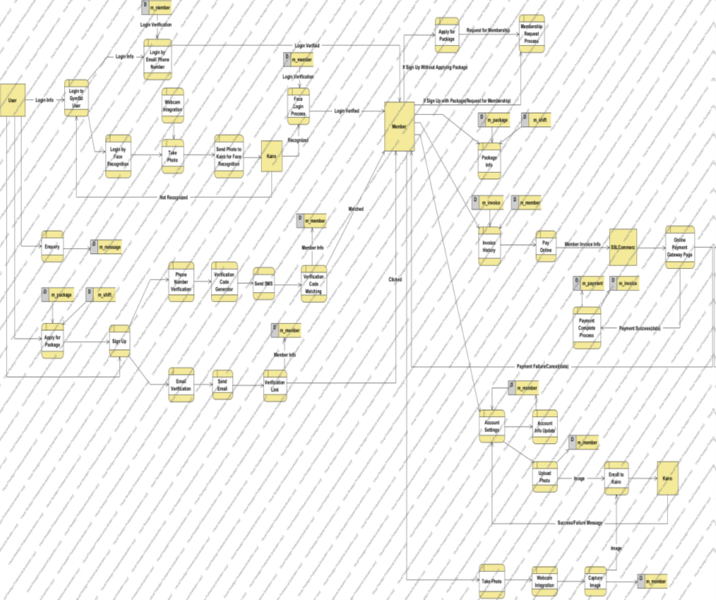

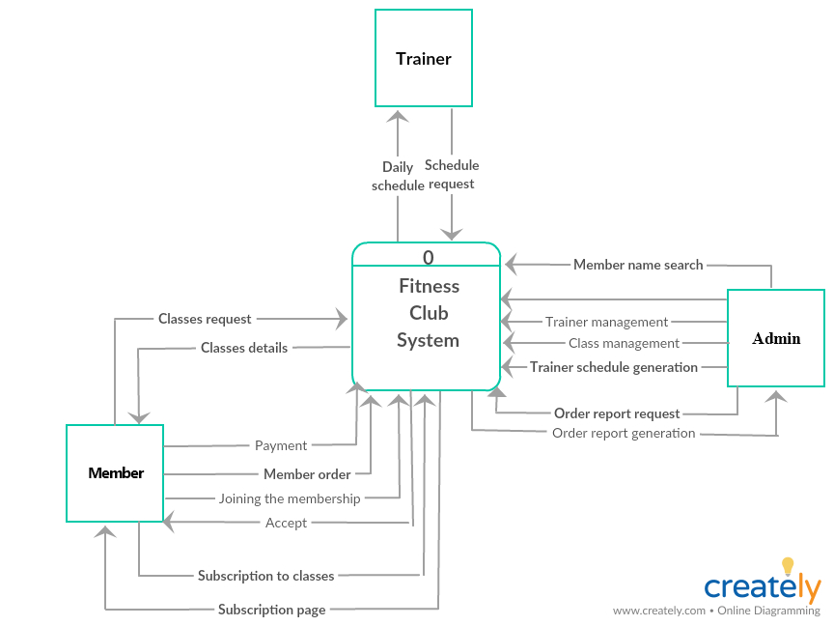

**DATABASE DESCRIPTION**

**GYM:-**

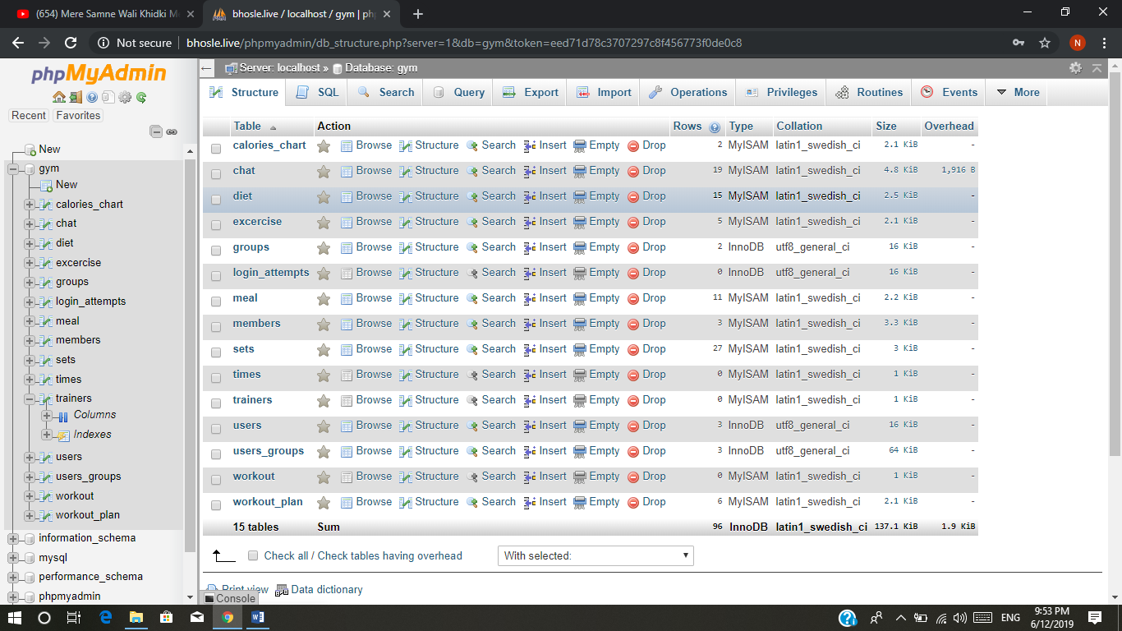

**CHAT:-**

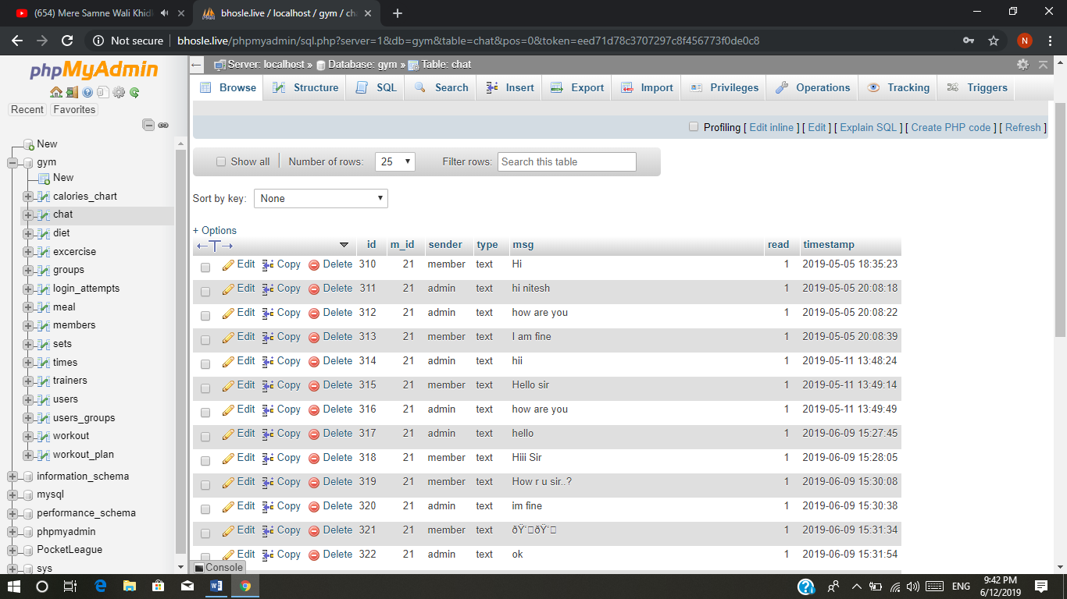

**DIET:-**

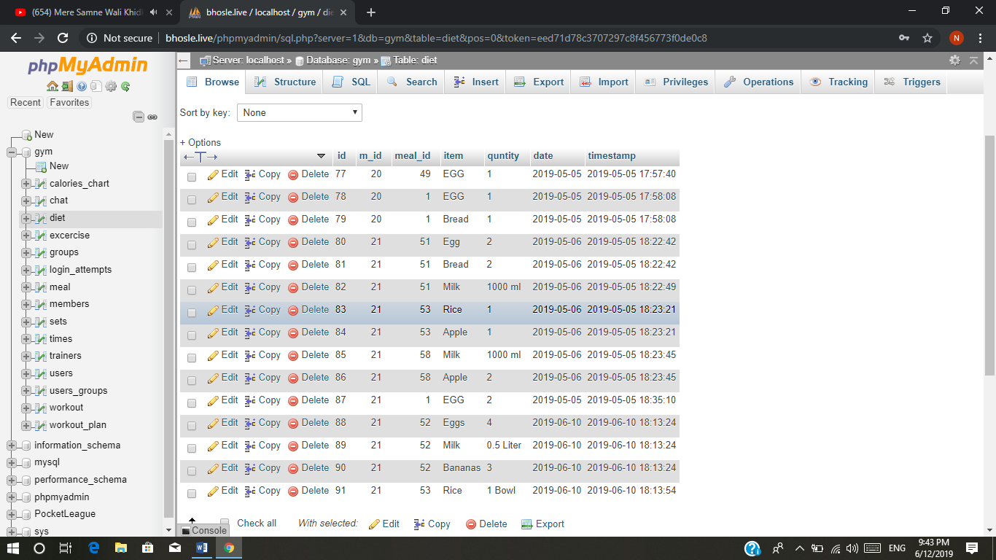

**EXERCISES:-**

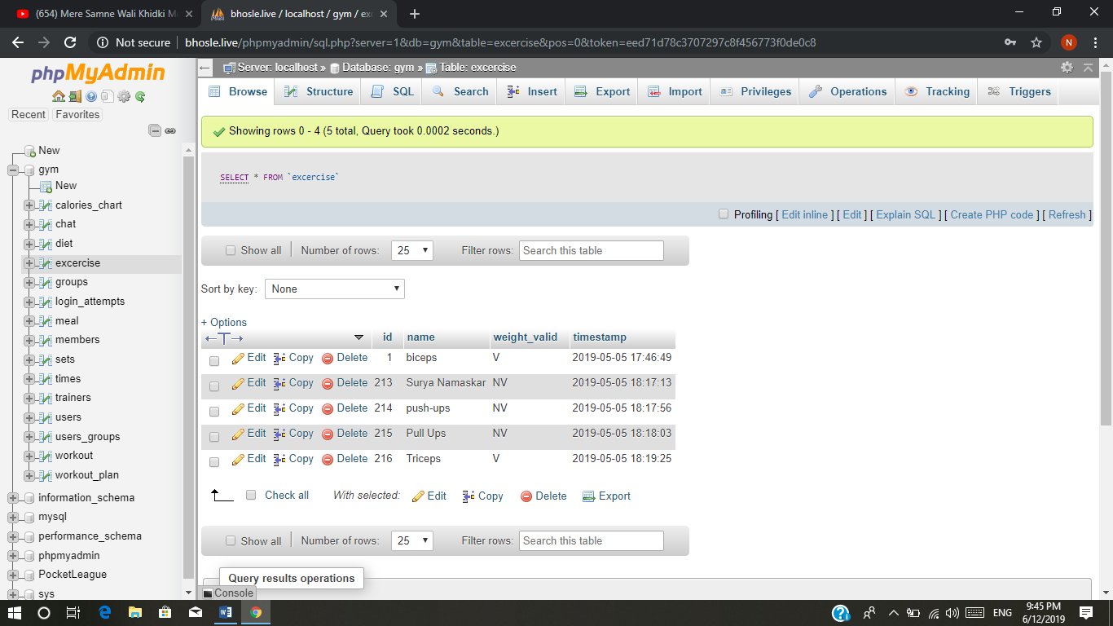

**GROUPS:-**

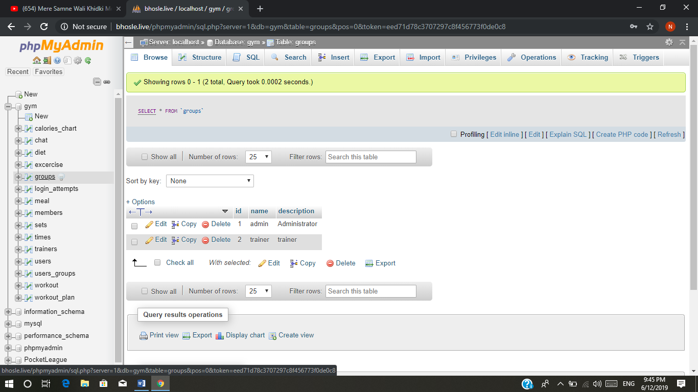

**MEAL:-**

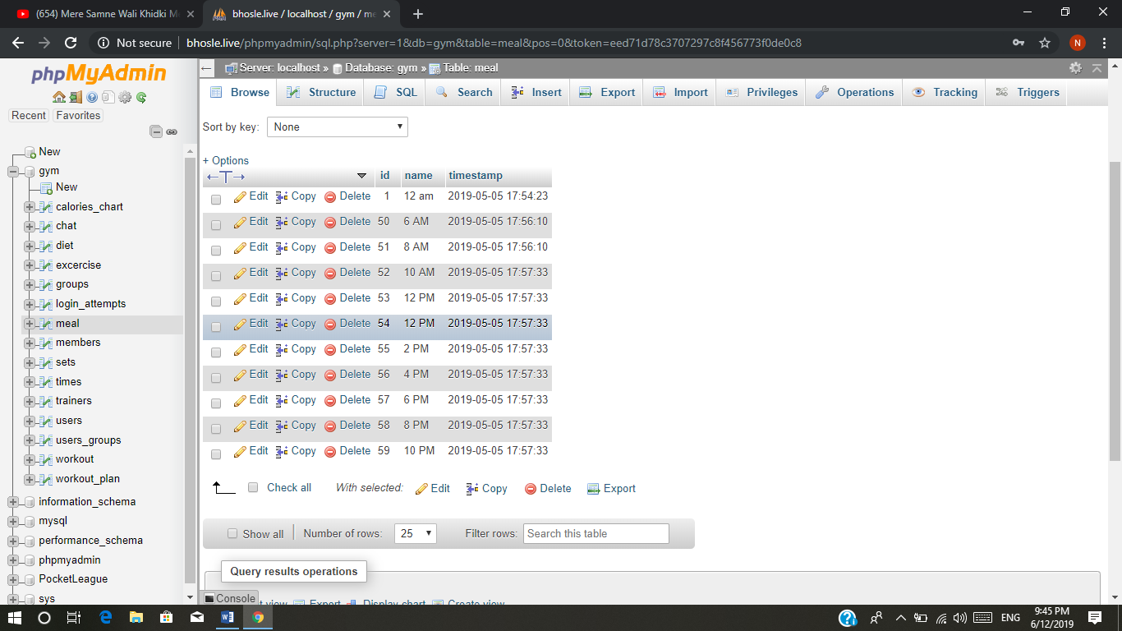

**MEMBER:-**

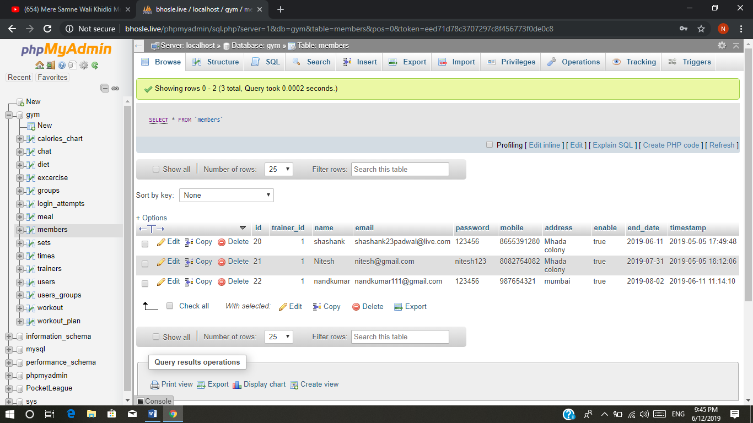

**SETS:-**

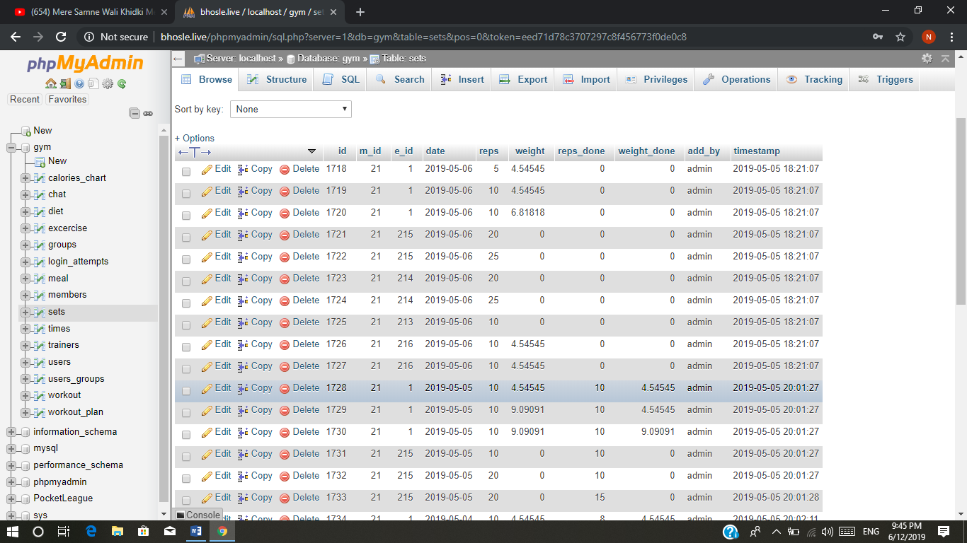

**TRAINER:-**

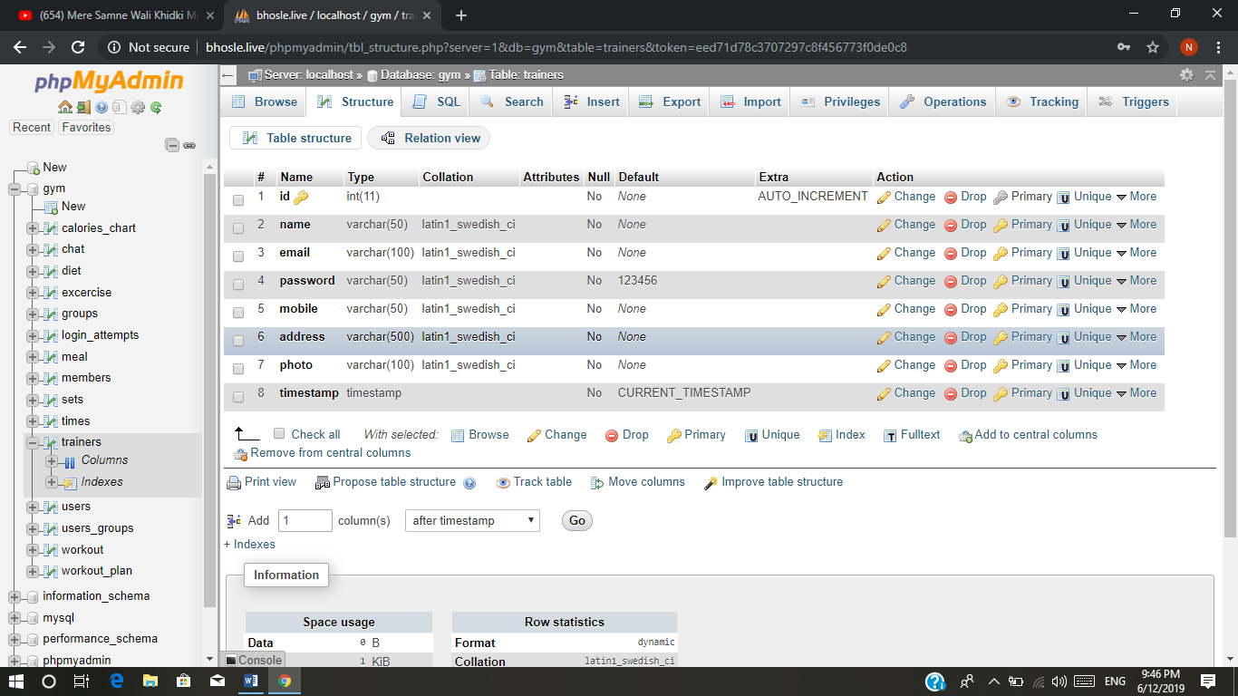

**CALORIES:-**

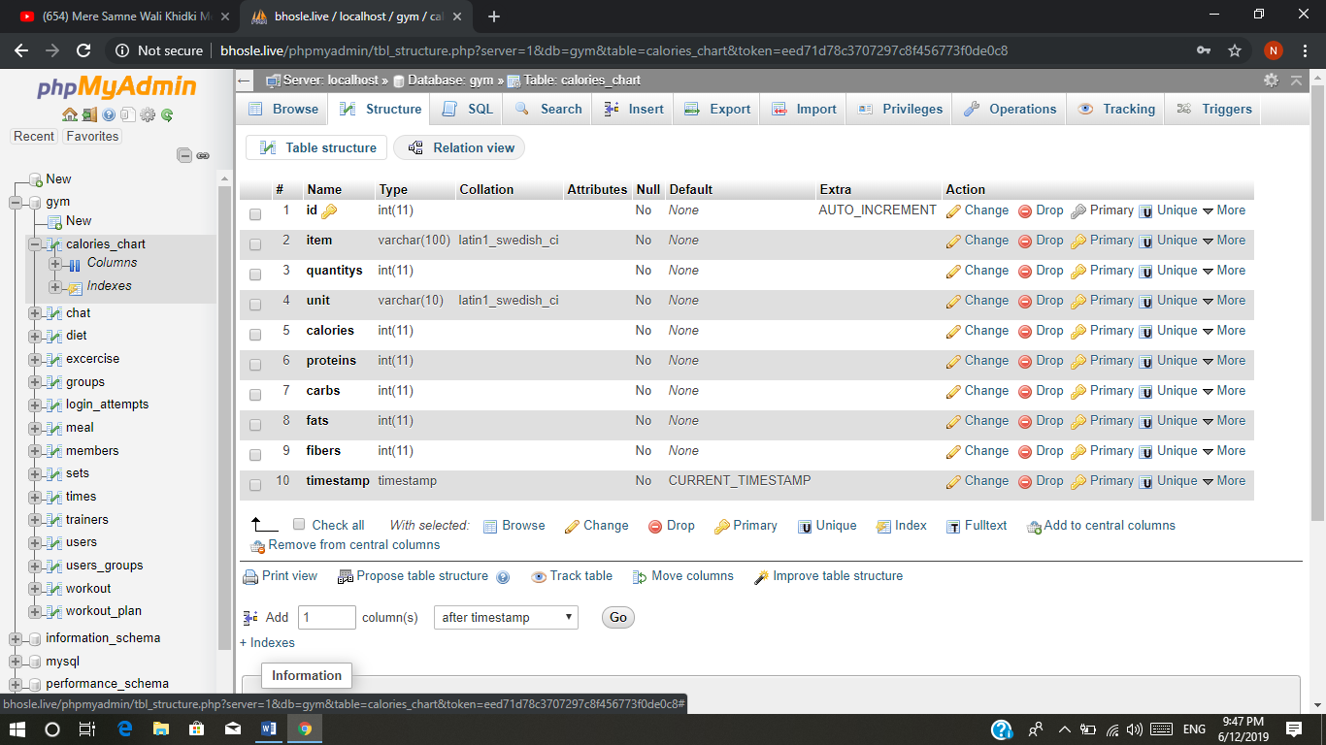

**USERS:-**

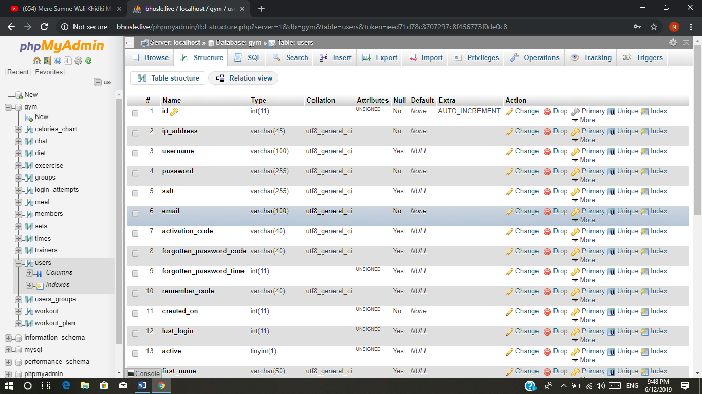

**TRAINERS:-**

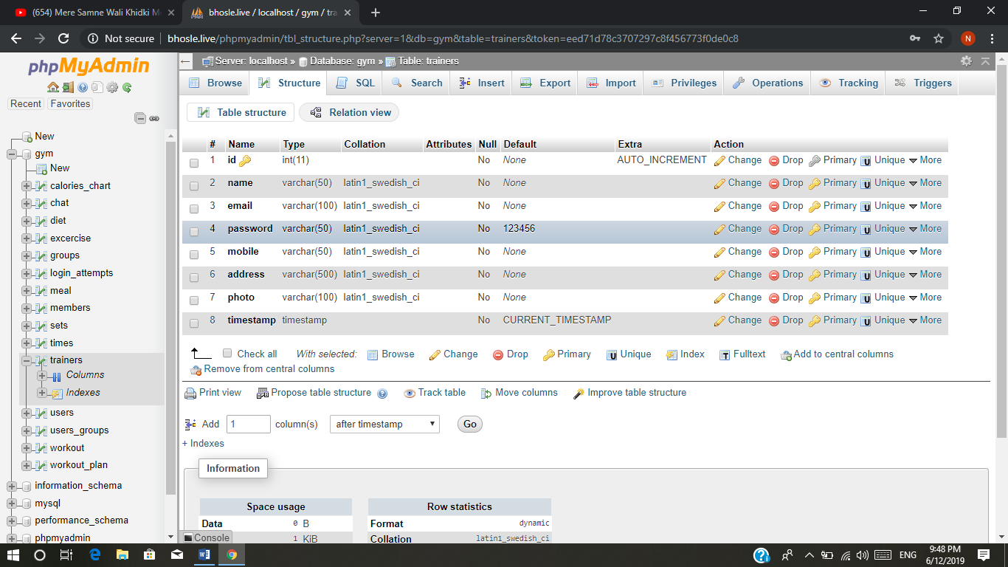

**GANTT CHART**

A Gantt chart, commonly used in project management, is one of the most popular and useful ways of showing activities (tasks or events) displayed against time. On the left of the chart is a list of the activities and along the top is a suitable time scale.

Each activity is represented by a bar; the position and length of the bar reflects the start date, duration and end date of the activity.

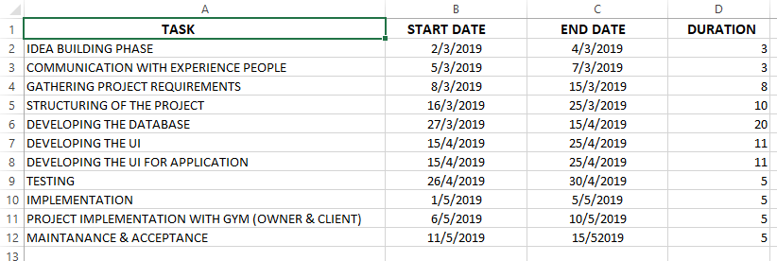

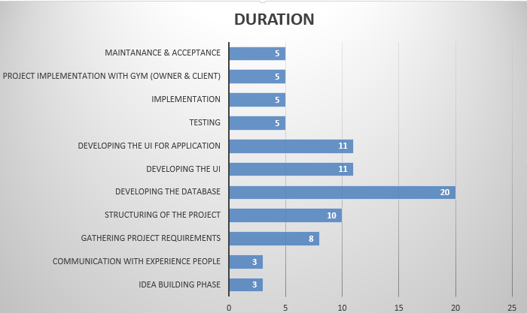

**Conclusions**

The “GYM AND FITNESS [HEALTH] AUTOMATION SYSTEM” is successfully designed and developed to fulfilling the necessary requirements, as identified in the requirements analysis phase, such as the system is very much user friendly, form level validation and field level validation are performing very efficiently.

The old manual system was suffering from a series of drawbacks.

The present project has been developed to meet the aspirations indicated in the modern age.

**Future Work**

The project has been developed in a very short period of time and all efforts have been taken so that this project is very efficient in its execution there still exists some scope of improvement in our project.

The following lists some of the enhancement that can be added incorporate into the project. Application of the project can be done more attractively. Database management and all maintenance module can be updated which helps the administrator.

More security measures can be taken.

There are also few features which can be integrated with this system to make it more flexible.

Below list shows the future points to be consider:

• Automated Fitness suggestion by enquiring the condition of the health.

• Real time Claim Processing Bot.

• Video conversation option for trainers and members.

• Online payment through face recognition.

• Barcode generation for membership card and using this, members can take entry to Gym.

• Finger print matching for taking entry to gym.

**BIBLIOGRAPHY**

**References**

**WEBSITES:-**

[1] [www.wikipedia.com](http://www.wikipedia.com)

[2] [www.tutorialspoint.com](http://www.tutorialspoint.com)

[3] <https://www.apachefriends.org/download.html>

[4] <https://jquery.com>

[5] <http://www.slideshare.net/jagaarj/database-design-normalization>

[6] <https://www.twilio.com/docs/quickstart/php/sms>

[7] <https://www.twilio.com/docs/quickstart/php/sms/sending-via-rest>

[8] <https://www.kairos.com/face-recognition-api>

[9] <https://sslcommerz.com/>

[10] <https://stripe.com/docs/custom-form>

**BOOKS:-**

**[1] PHP and MySQL Web Development by Luke welling**

**Website link:-**

<https://www.amazon.in/PHP-MySQL-Development-Luke-Welling/dp/9332582734/ref=sr_1_1?crid=2NITKG6U1P2QC&keywords=php+web+development&qid=1560574780&s=gateway&sprefix=php+%2Caps%2C285&sr=8-1>

# [2] Mastering HTML, CSS & Javascript Web Publishing by laura lemay

# Website link:-

# <https://www.amazon.in/Mastering-HTML-CSS-Javascript-Publishing/dp/8183335152/ref=pd_sim_14_1/258-8121710-8642916?_encoding=UTF8&pd_rd_i=8183335152&pd_rd_r=67dff6d3-8f2a-11e9-aff8-bb99849af766&pd_rd_w=I2WrF&pd_rd_wg=nm3M3&pf_rd_p=3ba80840-2950-4d64-ba61-c68a14bd0939&pf_rd_r=8SZVDKK4Z8ZQ4H2CC4XY&psc=1&refRID=8SZVDKK4Z8ZQ4H2CC4XY>

# [3] HTML 5 Black Book (Covers CSS3, JavaScript, XML, XHTML, AJAX, PHP, jQuery) 2Ed by DT Editorial services

# Website link:-

# <https://www.amazon.in/Black-Covers-JavaScript-XHTML-jQuery/dp/935119907X/ref=sr_1_2?keywords=jquery+books&qid=1560575732&s=books&sr=1-2>

# [4] Web Technologies: HTML, JAVASCRIPT, PHP, JAVA, JSP, ASP.NET, XML and Ajax, Black Book: HTML, Javascript, PHP, Java, Jsp, XML and Ajax, Black Book

# Website link:-

# [https://www.amazon.in/ Javascript/dp/8177229974/ref=pd_bxgy_14_img_2/258-8121710-8642916?_encoding=UTF8&pd_rd_i=8177229974&pd_rd_r=fd5ffcc1-8f2c-11e9-ac83-ffdb1b86ceff&pd_rd_w=Ir5ip&pd_rd_wg=kiXUc&pf_rd_p=92c5dc59-6da4-488e-ba00-262537223f6b&pf_rd_r=H0ED1RTSB6C9F5WFEMT7&psc=1&refRID=H0ED1RTSB6C9F5WFEMT7Web-Technologies-JAVASCRIPT-ASP-NET-](https://www.amazon.in/Web-Technologies-JAVASCRIPT-ASP-NET-Javascript/dp/8177229974/ref=pd_bxgy_14_img_2/258-8121710-8642916?_encoding=UTF8&pd_rd_i=8177229974&pd_rd_r=fd5ffcc1-8f2c-11e9-ac83-ffdb1b86ceff&pd_rd_w=Ir5ip&pd_rd_wg=kiXUc&pf_rd_p=92c5dc59-6da4-488e-ba00-262537223f6b&pf_rd_r=H0ED1RTSB6C9F5WFEMT7&psc=1&refRID=H0ED1RTSB6C9F5WFEMT7)

# [5] Android Application Development (With Kitkat Support)

# By Pradeep Kothari

# Website link:-

# <https://www.amazon.in/Android-Application-Development-Kitkat-Support/dp/9351194094/ref=pd_bxgy_14_img_3/258-8121710-8642916?_encoding=UTF8&pd_rd_i=9351194094&pd_rd_r=217449b5-8f2d-11e9-ab41-1fb0bb60f639&pd_rd_w=VPNyl&pd_rd_wg=ThaX9&pf_rd_p=92c5dc59-6da4-488e-ba00-262537223f6b&pf_rd_r=E884R3YDXJSSEWKQYEKR&psc=1&refRID=E884R3YDXJSSEWKQYEKR>

# [6] Andriod User Interfce Design: Implementing Material Design for Developers

# Website link:-

# <https://www.amazon.in/dp/9332570922/ref=sspa_dk_detail_1?psc=1>